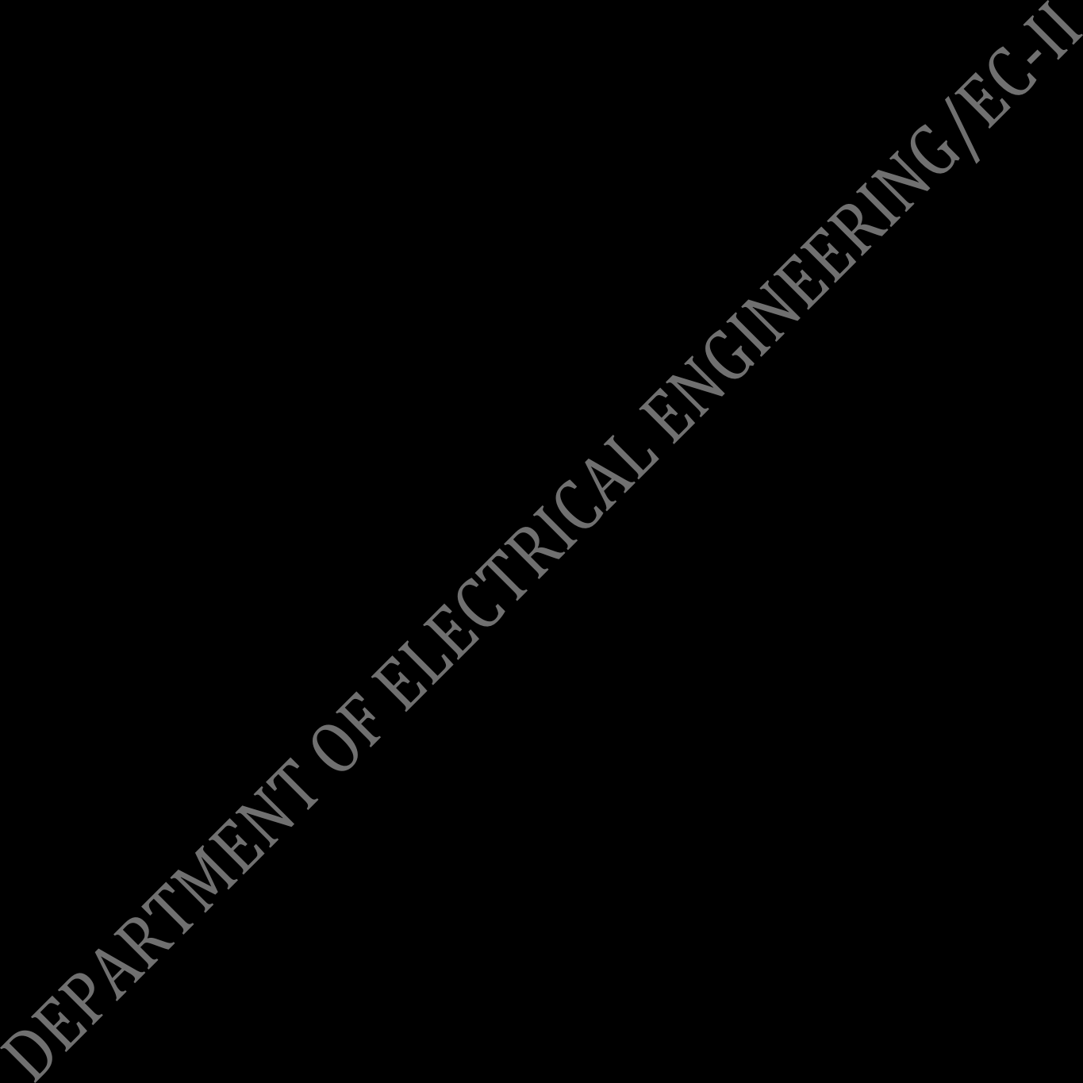
QUESTION BANK
DEPARTMENT OF ELECTRICAL ENGINEERING
GOVT. POLYTECHNIC,JAJPUR

ENERGY CONVERSION-II SEMESTER-5TH

SHORT QUESTIONS
- Why rotor slots of an induction motor are skewed?
- Write down the advantages of stationary armature of alternator?
- What is plugging?
- What do u mean by voltage regulation of an alternator?
- What is damper bar or damper winding?
- State the applications of synchronous motor.
- Write down the uses of universal motor.
- Define the step angle of a stepper motor.
- What are the conditions required for parallel operation of 3 phase transformers?
- Why parallel operation of an alternator is required?
- What is hunting?
- What is v and inverted v curves of synchronous motor?
- What are the different vector groups of 3 phase transformer winding connections?
- What do you mean by an infinite bus?
- Which type of alternators is used in hydroelectric power plant and why?
- What is he relation between electrical degrees and mechanical angle of an alternator?
- State the different between coil pitch and pole pitch.
- State pitch factor and distribution factor.
- Why a starting winding is needed for a single-phase motor?
- What is the difference between a power transformer and distribution transformer?
- Write the applications of universal motor.
- Why transformer rating is expressed in KVA?
- What is voltage regulations?
- What is slip of an induction motor?

LONG QUESTIONS
- Derive the equation for distribution magnetic stepper motor.
- Explain the working of permanent magnetic stepper motor.
- Explain the double field revolving theory in single phase induction motor.
- What are the advantages and conditions for parallel operations of three phase transformers?
- Describe the speed-torque characteristic of three phase induction motor.
- What is armature reaction in an alternator? Explain with phasor diagram the effects of generated voltage when load is (i) Resistive (ii) Pure inductive (iii) Pure capacitive
- Explain the effects of change of excitations of a synchronous motor driving a constant load.
- Explain the construction, working principle and applications of universal motor.
- Explain working principle of 3 phase I.M.
- Derive the condition for maximum torque of 3 phase I.M. under running condition,
- Derive expression for distribution factor of an alternator.
- Explain how 3 phase supply produces a rotating magnetic field.
- Explain about armature reaction of alternator.
- Explain how a synchronous motor acts as a synchronous condenser with the help of vector diagram.
- Explain hunting of synchronous motor.
- State and explain maintenance schedules of a power transformer.
- Write in brief about the applications of synchronous motor.
- Write in brief about field revolving theory?
- Write in brief about principle of operation of shaded pole motor.
- Write in brief about the total maintenance of 3 phase transformers.
- With neat sketch explain the working of a repulsion motor.

